Janet Douglas Obituary

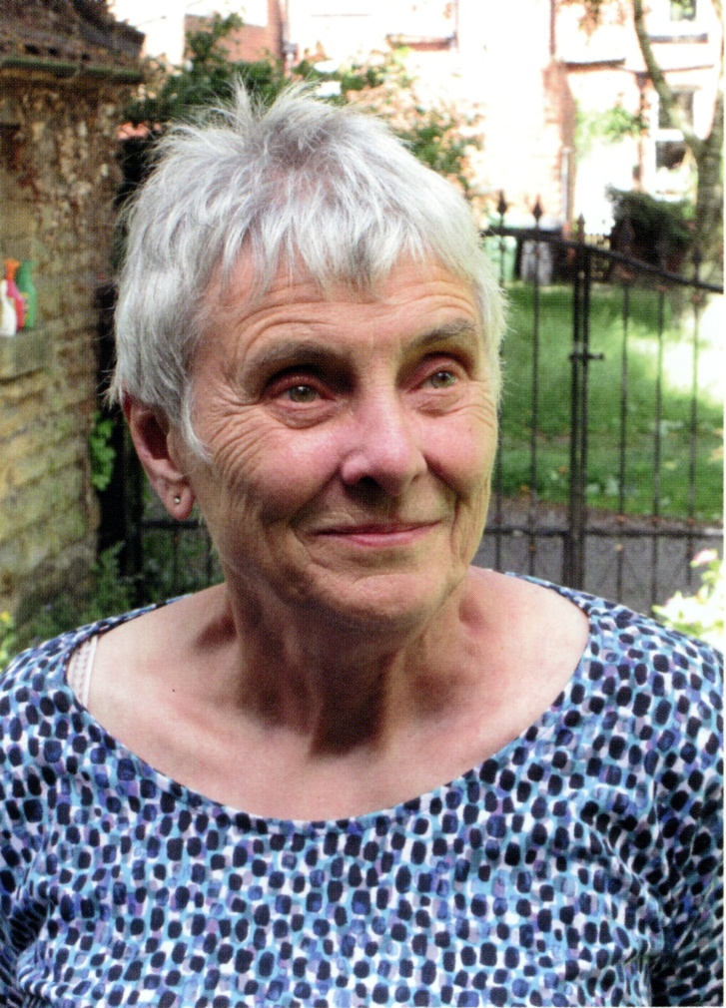
Members will be sorry to hear of the recent death of Janet Douglas aged 81. Many of us will have attended Janet’s wonderful talks about the history of Leeds and its architecture and people, and enjoyed her fascinating tours of the city’s streets, historic buildings and churches. As a recent tribute said, she combined deep knowledge based on her research with a very lively style which made her talks and walks both informative and entertaining.
Janet was born in Droylsden, Greater Manchester in 1943. Her father worked in the chemical industry, while her mother was a school secretary. According to her sister, her teenage enthusiasms were CND, art, history, Rock &Roll, and Roman Catholic boys on motorbikes.
She came to Leeds in 1960 to study history at the University and never left. In the 1970s she became a lecturer in Leeds Polytechnic’s Department of Humanities and Social Studies. When the department began its own Combined Studies degree in 1980 this allowed Janet to lecture in both Politics and History, including courses on the history of Leeds. This encouraged the development of her tremendous interest and research into the architecture and architects of Leeds.
She became a very active member of several Leeds societies. Perhaps most prominently, with Ken Powell, she was a joint founder of the West Yorkshire Group of the Victorian Society; but she was also a longstanding active member of the Thoresby Society and the Leeds Philosophical & Literary Society, and latterly she became an adviser to Leeds Civic Trust’s Historic Plaques Group.
Janet wrote several valuable booklets about Leeds. These included two in the Victorian Society’s Walks series – No. 4, with Ken Powell, Leeds City Centre walks, and No. 6 Three Leeds Suburban Walks with Ken again and Chris Hamond. She and Ken also produced a valuable guide to St John’s Church, New Briggate. She wrote many articles too. In 2012 she was a major contributor to Building A Great Victorian City: Leeds Architects and Architecture 1790 – 1914 (edited by Chris Webster). In the last five or six years, her output seemed to be increasing, rather than diminishing – there were articles about the women members of The Leeds Library; about the Victorian congregations of Leeds Parish Church; and most recently about the 1936 anti-fascist Battle of Holbeck Moor. In 2021 she was a leading participant in the conference about Leeds Minster and in 2023 she organised a marvellous conference about St John’s, New Briggate.
Janet was good fun, generous in sharing her research, and always willing to help and encourage people with theirs. To all of us who were planning future Leeds history activities with her, Janet’s death was a great shock and a great sadness. She really will be missed.

Dr Kevin Grady
Director of Leeds Civic Trust (1987 – 2016)

