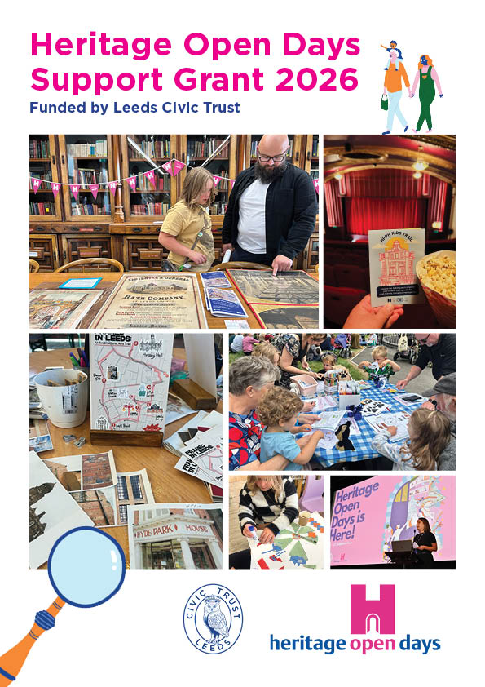
Heritage Open Days Support Grants
Following the success of last year’s Heritage Open Days grants, Leeds Civic Trust is delighted to offer another round of small grants to support free, family-friendly activities that help children and families take part in the 2026 Heritage Open Days festival.
In 2025 we supported 13 trails and activities across Leeds designed to welcome families. These encouraged many children and parents to attend Heritage Open Days for the first time and gave organisations the chance to explore creative ways of sharing local heritage. Feedback from participants and organisers was overwhelmingly positive, and we are excited to build on this success.
Our Heritage Open Days Support Grants are aimed at helping organisers deliver fun, accessible experiences during the festival, which will take place across Leeds from 11–20 September 2026.

What We’re Looking For
We welcome applications from individuals, community groups, and organisations. Events must take place within Leeds during the festival dates, be free and open to the public, and be family-friendly. Please consider the timings of your event to ensure families can attend.
We encourage activities that:
- Include interactive elements, crafts or storytelling
- Help children and families explore and learn about heritage in an engaging way
- Invite participants to discover everyday life in Leeds across the ages
Activities that provide playful, creative, or immersive experiences for younger audiences are especially welcome.

Why We’re Offering These Grants
These grants are designed to help more families experience Heritage Open Days, to encourage first-time visitors, and to support free, inclusive activities across the city. They are also an opportunity for families to discover local heritage together and to engage with Leeds’ rich history in meaningful ways.

Theme for 2026: Everyday Histories
The national theme for 2026 is Everyday Histories, exploring daily working life through the ages. From the butcher, baker, or candlestick maker, to the routines, skills, and cherished rituals of generations past, this theme invites families to discover how ordinary people lived and worked in Leeds.
This could include exploring skills and trades, everyday routines, or the stories of local workers and communities. Families can uncover history through interactive, creative, or immersive experiences in factories, kitchens, gardens, dockyards, and more.

Celebrating Leeds 400
In addition to the theme, 2026 marks a remarkable milestone 400 years since Leeds received its first Royal Charter. Events that explore how communities or places have changed over time, share local or everyday stories, highlight notable people, or encourage families to think about the city in the past, present, and future are particularly welcome.
We hope to see activities that celebrate Leeds 400 in ways that feel meaningful, inclusive, and engaging for families and children.

What We Cannot Fund
We are unable to fund activities that:
- Promote political or religious beliefs or are primarily fundraising or sponsorship events (this does not exclude educational talks about politics or religion)
- Are for-profit activities
- Take place outside Leeds
Please note that we have a limited funding pot, so while we hope to support as many events as possible, some applications may not receive funding.

If Your Application Is Successful
Successful applicants should register their event on the national website by 14 June to be included in the Leeds online listing guide. We’ll also ask you to share feedback, photos, short videos, or a brief story showing how the grant benefited your community, along with completing a short post-festival questionnaire.
If promoting your event on social media, please tag @LeedsCivicTrust and the Leeds HODs channels. Make sure to include Heritage Open Days and Leeds Civic Trust Festival on all printed and digital materials.
We want your involvement to stand out! We ask that you use Heritage Open Days bunting and banners at your event, which you can order from the national website or request from Leeds Civic Trust. We have some limited stock!

How to Apply
To apply, please email a completed application form to office@leedscivictrust.org.uk by 18 May 2026.
If you would like to discuss your project idea or need more information, please do get in touch.
See below for the application form.
- Project / Activity name (if any)

- Registered name of organisation/charity/individual to which any grant would be made payable

- Charity Registration number (if applicable)

- Contact Name

- Email address & phone number

- Planned event dates (please note, events must take place between 11 – 20 September)

- Please describe your project (no more than one side of A4).

- What (apart from the money) will help make it happen, and do you have this already? (e.g. volunteers, equipment a suitable space)

- Amount requested (between £50 and £250)
- How will the money be spent? (your expected budget, include items such as; room hire*, equipment fees etc if these are required)
*if you are unsure about where to host your event, please feel free to get in touch with us and we may be able to match your event with an existing Heritage Open Day venue)

- What kinds of people will benefit from this funding e.g. children, families, people from specific communities, and how many people do you think will benefit?

- How will you publicise your project and acknowledge the Trust’s involvement?

